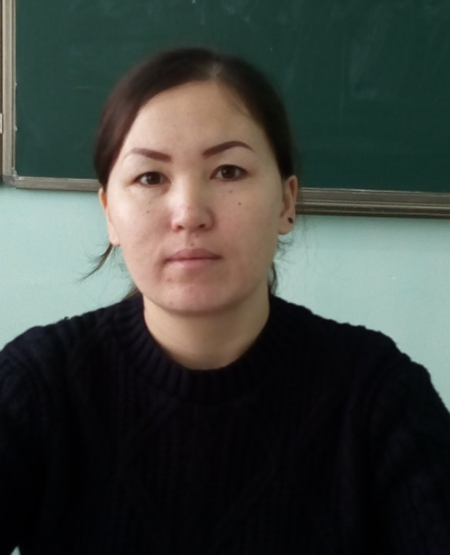

Акмолинская область, Аршалынский район, п.Аршалы

КГУ «Агротехнический колледж № 4, п. Аршалы».

Преподаватель английского языка, 2-категория

Тема урока  **The adverb Наречие**

**Тип урока:** урок обобщения и систематизации знаний.

**Цель урока:**

***образовательная:***закрепление и систематизация изученного материала;

***воспитательная:***воспитание культуры общения, активности на уроке;

***развивающая:***развитие речевой активности, памяти, образного мышления, интереса к предмету.

**Задачи:**

* отработать лексику по теме “Наречия”;
* закрепить употребление наречий и их место в предложении;
* отрабатывать навыки аудирования, поискового чтения, говорения.

**Оборудование урока:**

* классная доска;
* проектор и экран;
* наглядные материалы:

-слайды (глаголы, наречия);  
-текст физ.минутки;  
-раздаточный материал:  
- -карточки грамматических заданий;  
-тексты;  
-иллюстрации (глаголы-действия, наречия)

**План урока**

**I**. Мотивационно-ориентационный этап

* организационный момент;
* постановка цели и задач урока.

**II.**Актуализация опорных знаний

* повторение глаголов
* повторение наречий

**III.**Операционально-исполнительский этап

* лексическое задание;
* аудирование (слайд);
* грамматическое задание.

**IV.**Физ.минутка

**V.**Этап закрепления

**VI.**Рефлексивно-оценочный этап

**Ход урока**

**I. Мотивационно-ориентационный этап**

**1. Организационный момент.**

**T:** Hello, boys and girls! Sit down, please!

Nice to see you again!

**Cl:** Hello, teacher!

**T:** How are you today?

**P1**: I am fine!

**P2:**I am O.K., thank you.

**P3:**I am well, thanks.

**T:**I am glad you are O.K. Let’s start our English lesson.

**T:** Now we should revise the words and grammar material.

* 1. ***Работа со слайдами: слайд 1 (6 стр)***
  2. **Выберите правильную форму слов, данных в скобках. (составит пред. корточка)**

**Грамматическое задание.**

**T:**Let’s to. Your next task is to complete the sentences with the correct verb form. Some of you have yellow cards, others have red cards.

Учащимся предлагаются дифференцированные задания.

1.Выбрать правильную грамматическую форму глагола (для слабых и средних учеников)

2.Вписать подходящий по смыслу глагол, поставив его в правильную форму.

1. Can she run … ? (quick, quickly)
2. Be …! Don’t break the mirror. (careful, carefully)
3. Look! The young sportsman is swimming very (quick, quickly)
4. His new manager is lively and (energetic, energetically)
5. Now I … skate four times a week. (usual, usually)
6. The girl was … at jumping and running. (good, well)
7. What’s the matter with you? – I feel … .(bad, badly)
8. The boy works … (hard, hardly) at his English/
9. Oh, it’s too …! I should leave.(late, lately)
10. It takes me … 40 minutes to get to the swimming pool. (near, nearly)
11. The sportsman was tired and could … speak. (hard, hardly)
12. They often walk / walks in the park.
13. He usually speak / speaks English at the lesson.
14. I never play / plays football.
15. We sometimes play / plays computer games.
16. She always watch / watches TV in the evening.
17. My friend often ride / rides his bike.
18. I usually listen / listens to music.
19. He usually play / plays basketball.
20. He always speak / speaks Russian.
    1. ***Слайд 2 (3 стр)***

*1 стр.* **T:**Look and repeat the verbs (устно)

**P1**: sometimes - иногда

**P2:**never- никогда

**P3:** usually-редко

**P4:**always- всегда

**P5:**often-часто

**P1**: I sometimes speak English. Я иногда говорю по-английски.

**P2:**He usually walks in the park. Он обычно гуляет в парке.

**P3:** My friend often plays football. Мой друг часто играет в футбол.

*2 стр* 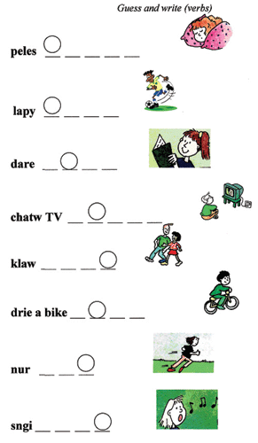(письменно)

*3 стр.* **T:**Look and repeat the verbs (устно перевод)

**CL:** **T:**Thanks a lot. Now, please, read the sentences, choose the correct verb form and translate.

(Учащиеся смотрят на слайд, зачитывают предложения, выбирая верную грамматическую форму глагола, переводят на русский язык)

“sing, dance, sleep, walk, play football, ride a bike, watch TV, play tennis, listen to music, read, write, speak”.

* 1. ***Физ.минутка***
* **T:**Now we are coming to the iceberg, you should move and sing otherwise you may get cold.
* (Звучит музыка, учащиеся смотрят на слайд c текстом песни, поют песню и выполняют действия)
* Song: Let’s run, let’s sing,  
  Let’s dance, let’s swim,  
  Let’s fly  
  High in the sky.  
  Let’s walk, let’s jump,  
  Let’s ride a bike,  
  Let’s fly  
  High in the sky.

**5) Аудирование (индивидуально)**

**T:**Take the sheets of paper, I’ll pronounce the sentences, you should listen, find the correct letters and write them down in the columns.

1. Смотрим фильм
2. Друг-друга обесняем (задаем вопросы)
3. Задает вопросы в заде сидящего
4. Содержания 2 предложениям

**Dialogue**

T: Sometimes our life depends on our animals and we usually have a lot of problems with them.

Nick: Hi! I’m Nick!

Ally: Hi’ my name is Ally. This is Robo (the fat cat)

Nick: And this is Fifi (a little dog).I think Fifi likes Robo! We always walk in the park. Do you come here often?

Ally: Yes, we do. We come here every day, too. When do you usually come?

Nick: I get up very early because Fifi always wants her breakfast early. We go far a walk at 7 o’clock, and then I go to school.

Ally: Oh dear. Robo doesn’t get up early. He always gets up late, and I’m always late for school.

Nick: Bye, Ally. Nice to meet you.

Ally: Bye, Nick!... Robo. From now on we’re getting up early too!

T: What problems does Ally have? (Her cat gets up early and she is always late for school)

**Dialogue**

Tom: Hi Bob! I’m at the hotel “Plaza”, and my room is fantastic! There’s a phone next to the bed, and there is a fridge and a computer and a bathroom!

Bob: Really? And what’s in the fridge?

Tom: Cans of cola, and chocolate, too! And there is a TV, with a DVD player under it and an armchair in front of it!

Bob: Wow! Ana is there a CD player?

Tom: Yes! It’s on the shelf above the bed.

Bob! Cool!

Tom: And there’s a desk under the window, with a computer on it.

Bob: Excellent! Have a fantastic holiday!

**Dialogue**

S1: Do you watch sports?

S2: Yes, I do.

S1: How often do you watch sports?

S2: I rarely watch sports.

S3: Do you watch sitcoms?

S4: No, I don’t. I never watch sitcoms.

***Предложения:*** Sam usually walks in the park.

1. Sam never sings songs.
2. Sam often listens to music.
3. Sam sometimes plays football.
4. Sam always watches TV in the evening.
5. Sam usually rides his bike.
6. Sam often reads books.

( **Этап закрепления (7–8 минут))**

**T:**Look! Look! There is a box with the treasure. But to open it you need a code phrase. You’ve already got three code words, so it is your last task. Now you work in groups. Read the sentences, choose any 3 you like and code them with pictures. You have pictures, the glue and sheets of paper. Look at the example. (смотрят пример на слайде)

(Учащимся предлагаются тексты, они их читают, выбирают 3-4 предложения и зашифровывают их при помощи картинок и клея, после этого обмениваются своими шифровками и пытаются раскодировать послания, устно проговаривая предложения)

**Texts:**

**Anna**is eleven. She usually reads books. She often watches TV after school. She always walks in the park. She sometimes sings at home. She never plays football. She sometimes rides her bike. She often plays tennis. She always sleeps at night.

**Bill** is twelve. He never dances. He often rides his bike after school. He always plays football at the weekends. He sometimes watches TV in the evening. He never walks in the park. He usually reads comics. He usually speaks English. He often runs after school.

**David**is fifteen. He usually reads in the evening. He often plays tennis after school. He never plays football. He sometimes walks in the park with his friends. He often rides his bike. He sometimes runs at the weekends. He always sleeps at night. He never sings songs.

**T:**Well done! You are brilliant! Your fourth code word is **brilliant.**Please, write it down on the blackboard. (один из учащихся записывает последнее кодовое слово на доске)

Кодовое слово: **brilliant**

|  |  |  |  |  |  |
| --- | --- | --- | --- | --- | --- |
| Theater | | | | | |
| always | usually | often | sometimes | rarely | never |
|  |  |  |  |  |  |

***6) закрепительный тест***

|  |  |  |  |  |  |
| --- | --- | --- | --- | --- | --- |
| Music shows | | | | | |
| always | usually | often | sometimes | rarely | never |
|  |  |  |  |  |  |

|  |  |  |  |  |  |
| --- | --- | --- | --- | --- | --- |
| News | | | | | |
| always | usually | often | sometimes | rarely | never |
|  |  |  |  |  |  |

|  |  |  |  |  |  |
| --- | --- | --- | --- | --- | --- |
| Sports | | | | | |
| always | usually | often | sometimes | rarely | never |
|  |  |  |  |  |  |

**7) Рефлексивно-оценочный этап**

Questions: Do you like today’s lesson?

Why?

Do you interesting lesson?

OK. Let’s too.

**T:** You are right, my friends. Here are gold coins. Please, take the coins. If you work well and have no problems with the tasks, take three coins, if you have some difficulties take two coins, and if you don’t work hard and have many mistakes, take only one coin.

Проводится рефлексия (учащиеся берут из сундука определенное количество монет в зависимости от качества своей работы на уроке)

**T:**Thanks a lot for your work. Our trip has come to the end. Good bye!

Prince William and Kate Middleton's Love Story

**Беседа учителя с классом.**

T: Who like watching news? Why?

S: I like to watch sitcoms, because they are funny.

Показать диаграмму предпочтений уч-ся, которая предварительно содержит названия телепередач и пробелы для выставления их количества.

Развитие компенсаторных умений в беседе о телепрограммах при толковании составленной диаграммы.

5. Развитие диалогической речи продуктивного характера по теме “Кино”.

T: Do you like to watch films?

Ss: Yes, we do.

T: Invite somebody to watch a film.

S1: Are you free tonight?

S2: I think so. Why?

S1: Because there’s a new thriller / comedy on at Rodina.

S2: No, thanks. I don’t like thrillers.

S1: What about a comedy / thriller then?

S2: It’s not really my thing.

S1: OK. Let’s watch your favourite sitcom / sport programme.

S2: That’s a great idea.

S1: When would you like to meet?

S2: How about 6 pm?

S1: Great. How about some popcorn / pizza?

S2: Count me in!

S1: Bye.

S2: See you.